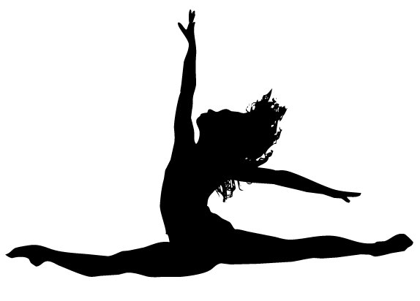
MHS Dance Team Auditions
Skill Expectations Form

On the day of the dance team audition you will be asked to demonstrate the skills below individually to the best of your ability. It would be to your advantage to begin practicing these skills now. If you would like a structured environment to practice and/or feedback then you should attend some/all of the optional technique clinics offered the week of auditions.
Skills
- pirouette (single & double)
- grand jete (leap off of straight leg)/saut de chat (leap off of developpe leg)
- chaine turns
- toe touch
- splits (right or left & middle)
- open second leap
- grande battement (kick)
- body isolations
- c-jump
- Tricks - stalls, kip up, flips, handstands, walkovers
- freestyle (improvisation – your own choreography)

Important Dates
- Optional Dance Clinic – Monday May 30th 7-8PM in the M-Room of MHS
- Optional Dance Clinic – Tuesday May 31st 7-8PM in the M-Room of MHS
- Mandatory AUDITION – Friday June 2nd at 3:30 PM in the M-Room of MHS

